
St. Nicholas Church | Millvale, PA
Fill out the form on the back of this flyer & Mail your check
Amish Pies
Nut Bread

St. Nicholas’ Easter

One Stop ShoppinG

OrDER By March 13th
Meatless Pierogies from Cop Out
Potato & Cheese $13.50/doz
Potato & Sauerkraut $13.50/doz
Cottage Cheese $14.50/doz

Choose From:

Nut Bread from Glencoe Gourmet
$17 per 13” Loaf

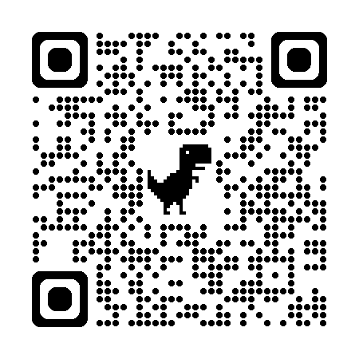
Easter Candy From Betsy Ann Chocolates
Fill out an order form in church or
order directly at betsyann.com or scan this QR code:
Be sure to place in the comments before
placing your order “St. Nicholas Church Fundraiser”
and select “PICK UP” so your candy will be ready for you at
St. Nicholas on March 29th with other items ordered.

Pick up Your ordered Items Palm Sunday, March 29th at St. Nicholas Church Hall between 11:00am to 1:00pm
To Mail your order: 1) Complete the order form below 2) Make your check to St. Nicholas Church 3) And mail BEFORE March 11th to: St. Nicholas Church Attn: Fundraisers 24 Maryland Ave Millvale, PA 15209

Name: ________________________________________________________________________
Address: ______________________________________________________________________
Email:__________________________________________ Phone: _______________________
Meatless Pierogies: ______# Potato & Cheese $13.50/doz _____# Potato & Sauerkraut $13.50/doz
______# Cottage Cheese $14.50/doz Item Total: $_________
Nut Bread (15”): $17/Each Quantity __________ Item Total: $___________
FULL ORDER TOTAL: $___________
Thank You for Supporting St. Nicholas’ Easter One Stop Shopping

